Assignment - Data Transform Activity

Amin Mahmoudi

Student ID : c0810349

1. a) Create a new table for your analysis called “employee_sales”.

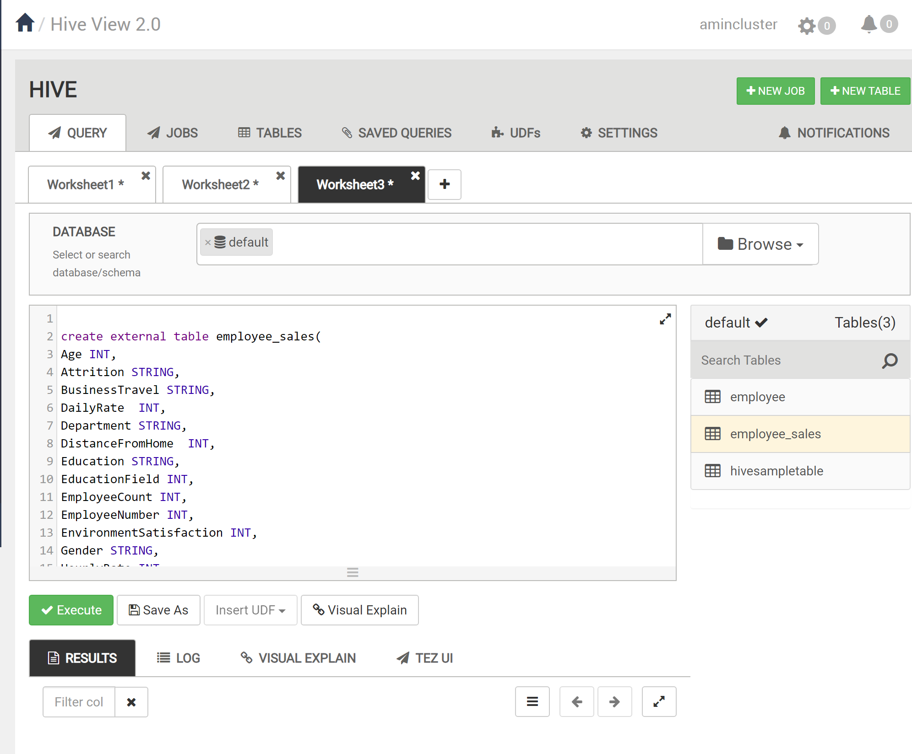

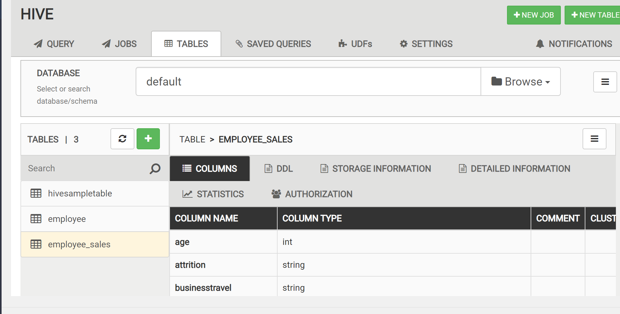

1. Load the table “employee” into this table.

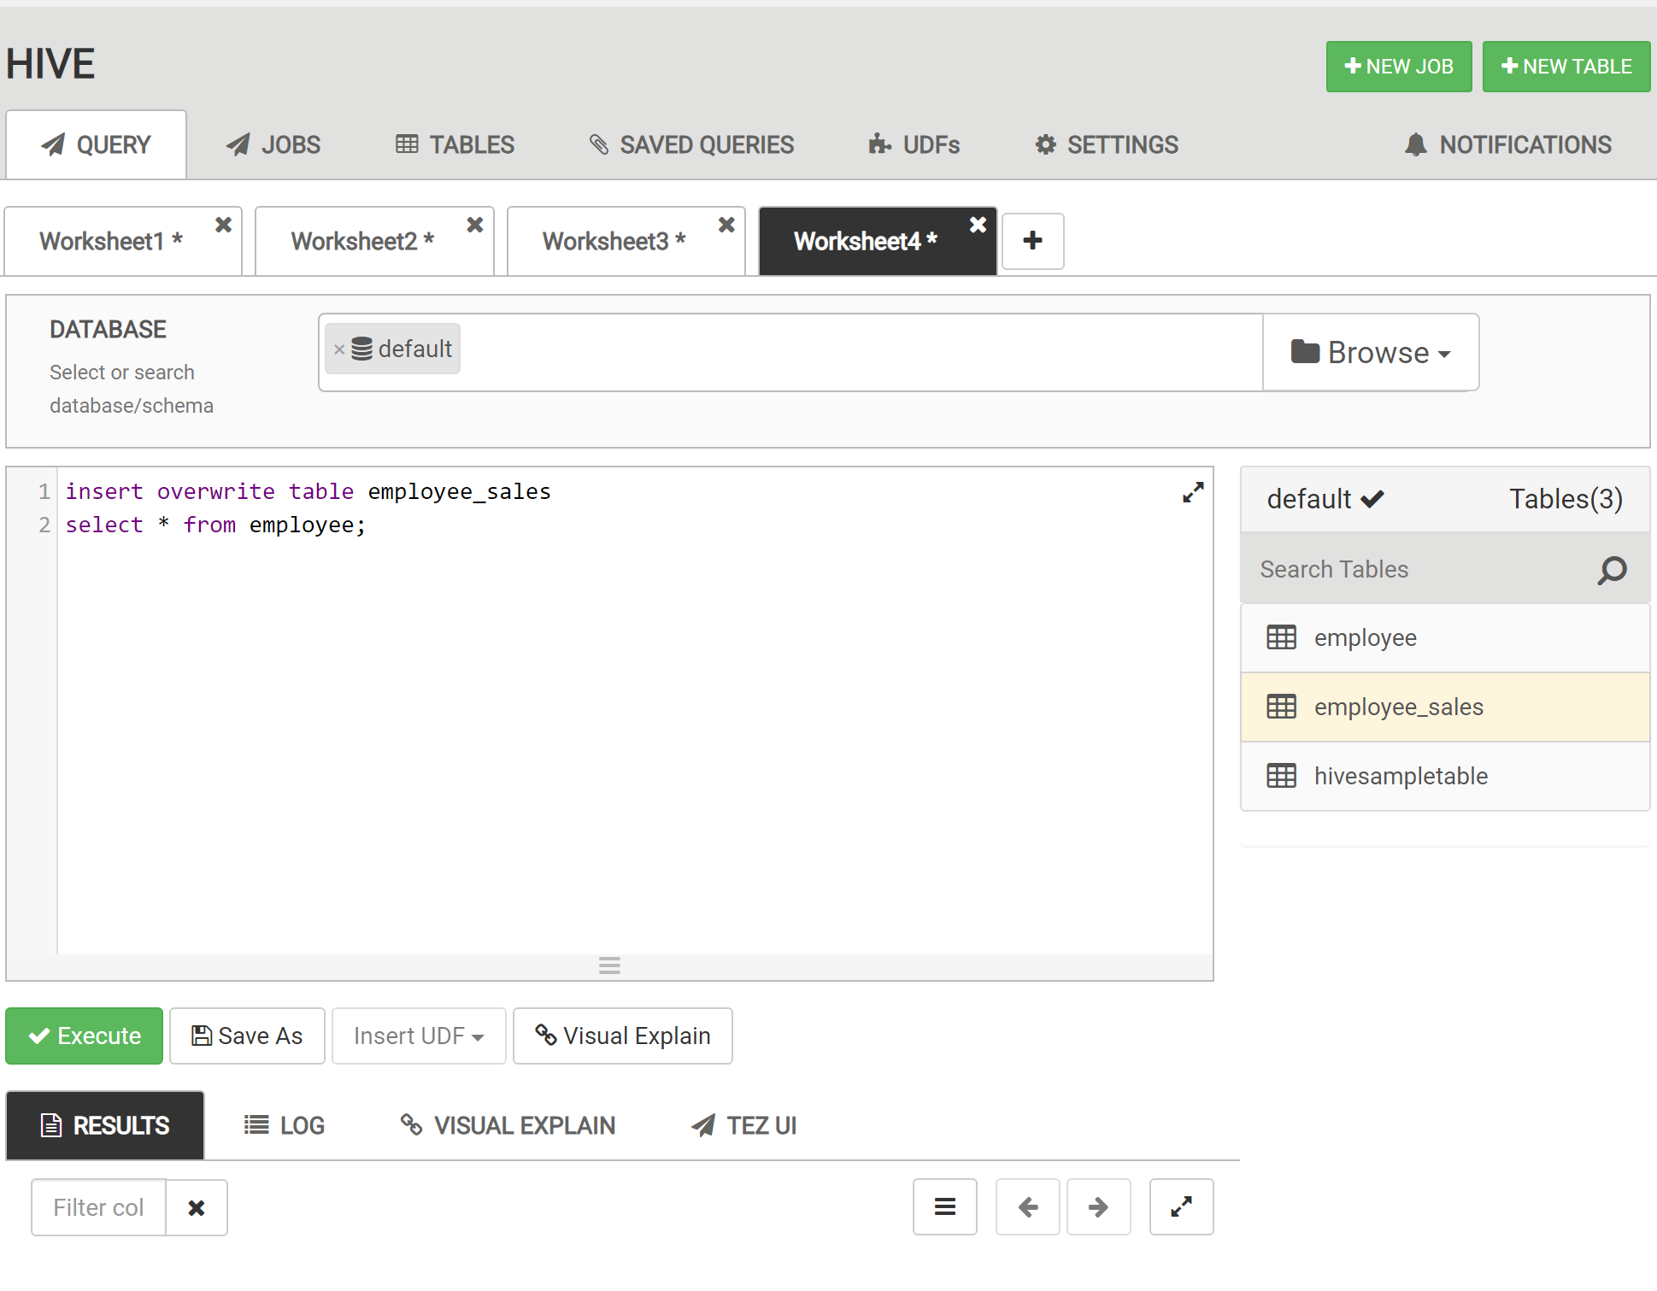

1. Select these columns: Attrition, Department, JobSatisfaction & MonthlyIncome.

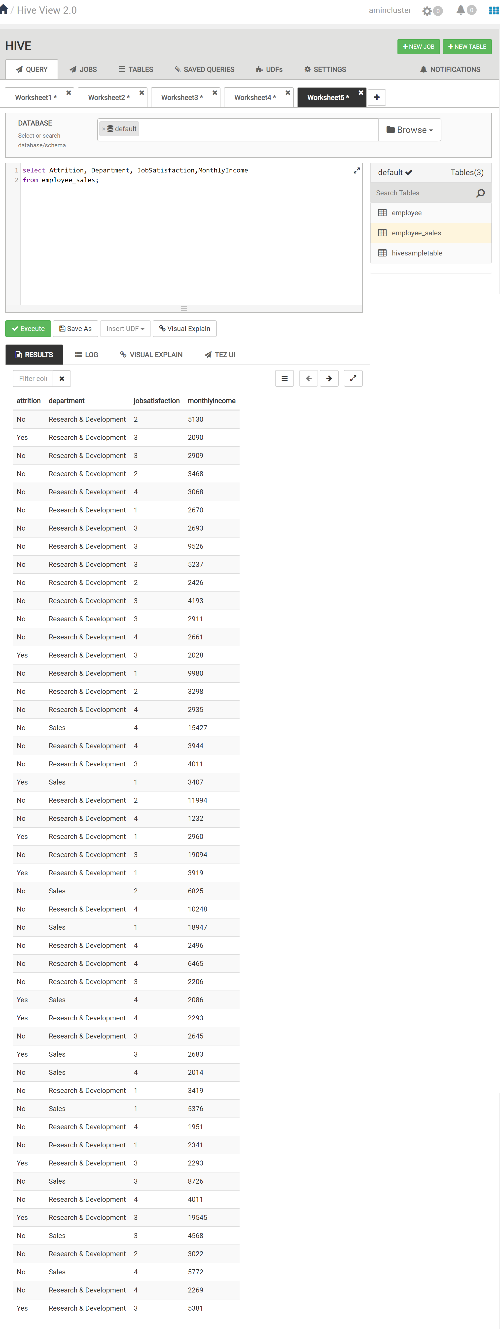

1. Round the data found in the “MonthlyIncome” column to the nearest $1000. (HINT: the SQL function to round a number is ROUND(obs, -3))

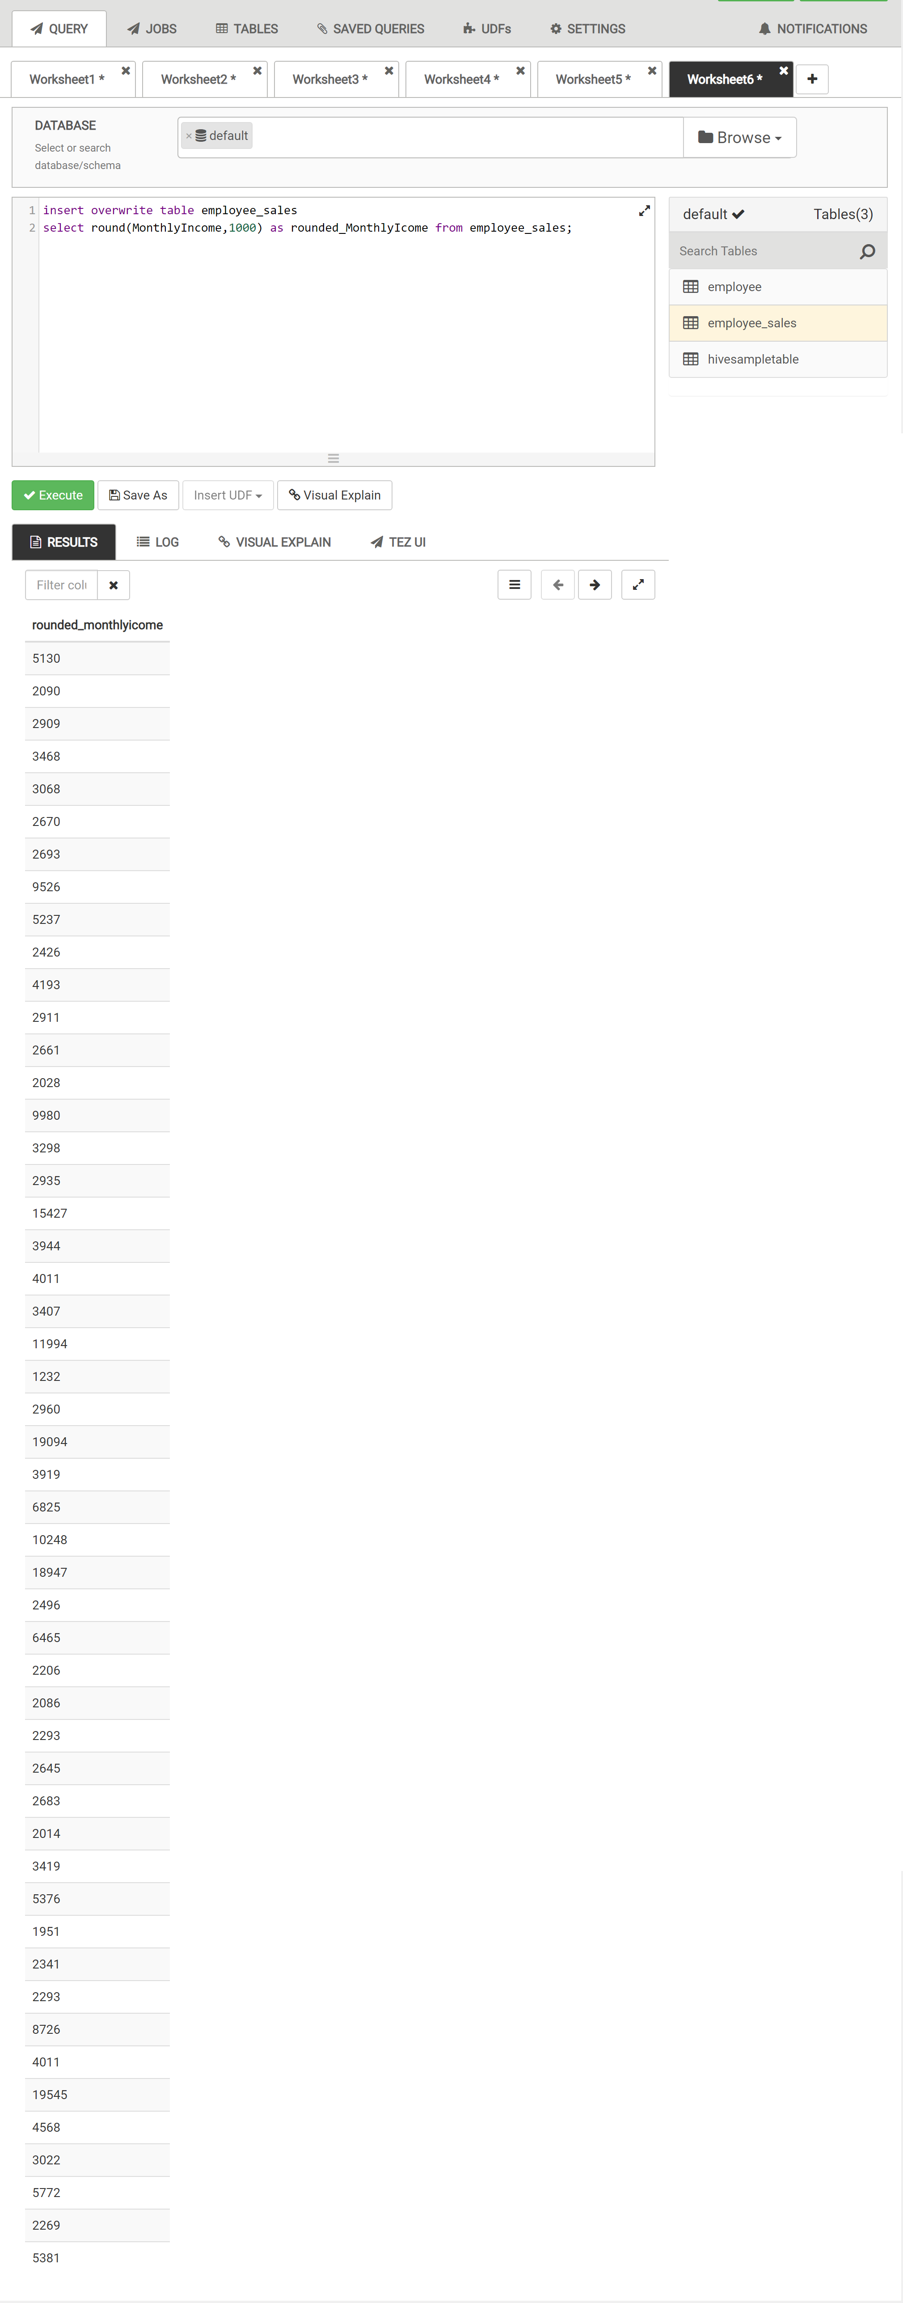

3 Filter the data to only look at those items in the “Sales Department”.

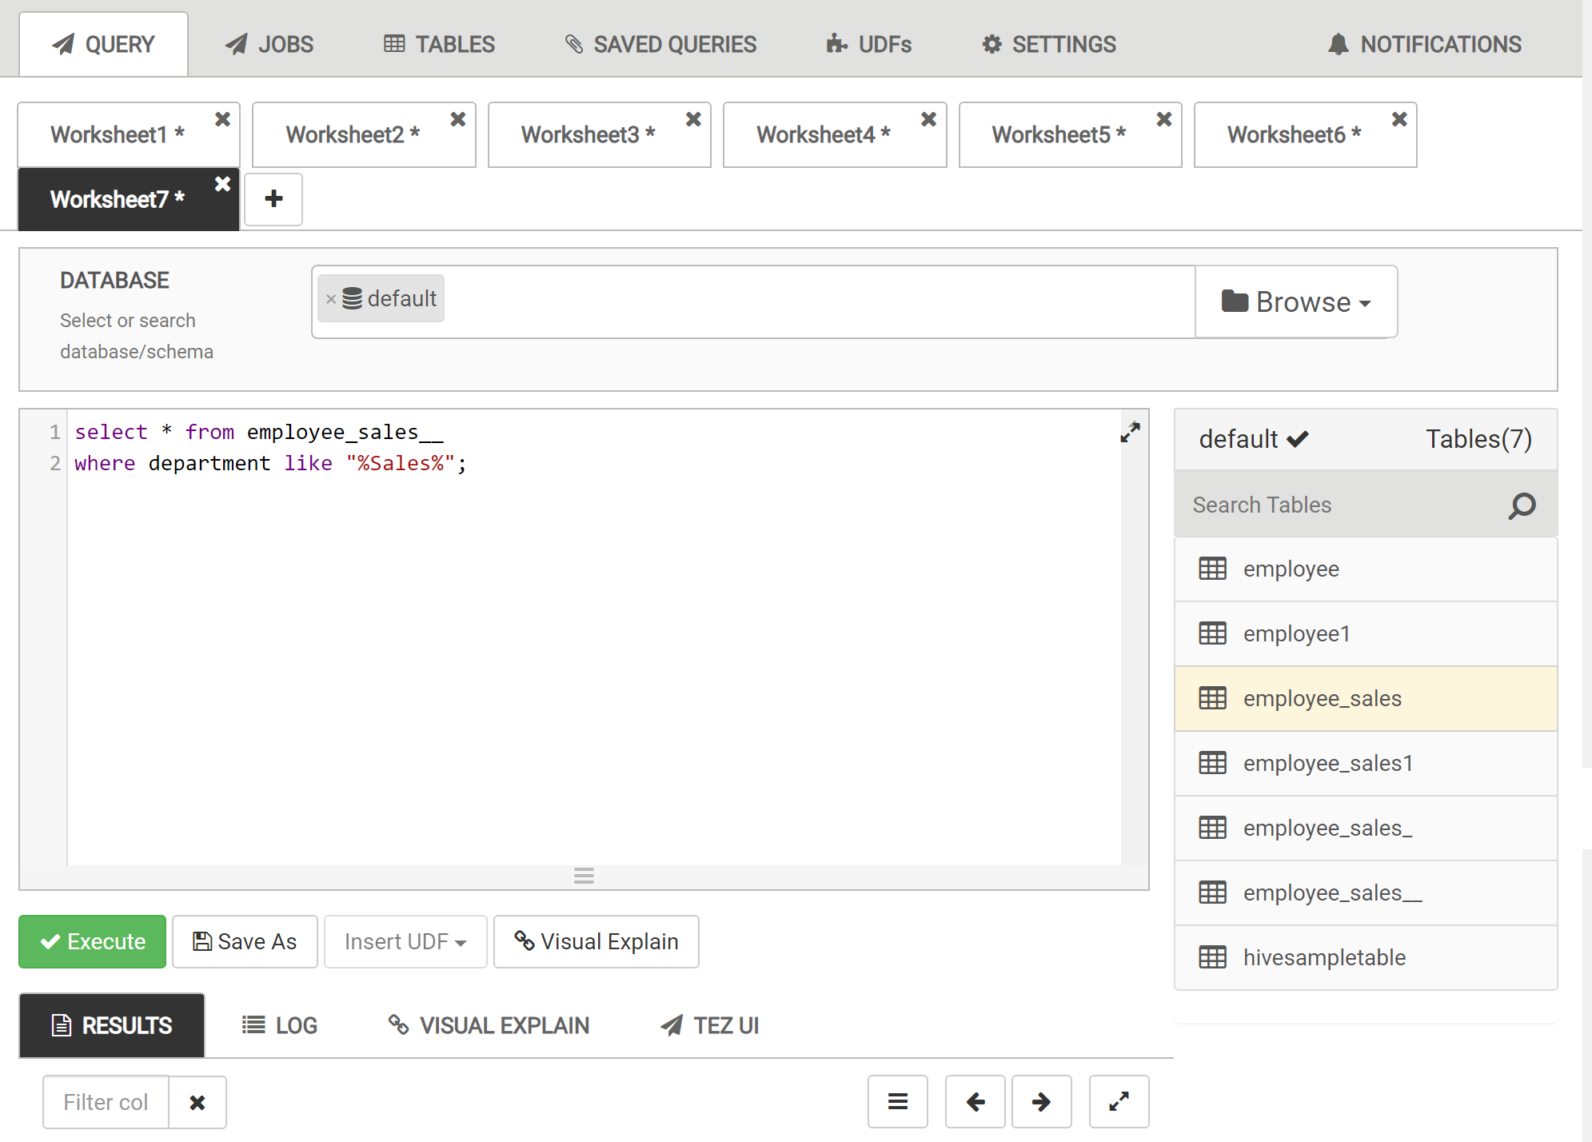

4) Order the data by “JobSatisfaction” from highest to lowest. (HINT: Use the DESC query)

